Deliverable 6: Implementation Roadmap
Company: Aegis Health Partners
Transforming Aegis Health Partners from manual spreadsheets to an AI-driven, Event-Based Polyglot architecture cannot happen overnight. This Implementation Roadmap outlines a strategic, phased rollout to minimize operational disruption to the telehealth doctors while progressively unlocking value.
1. Project Phases
The transformation is divided into three distinct phases to ensure stability before adding complexity:
- Phase 1: Foundation (Core Identity & Asset Migration)
  - Focus: Standing up the AWS EKS environment, deploying the core Snipe-IT (PostgreSQL) database, and the massive effort of sanitizing and migrating the legacy Google Sheets data.
  - Goal: Establish a single, accurate System of Record before any automation is enabled.
- Phase 2: Automation (Event Bus & Integrations)
  - Focus: Deploying Kong API Gateway, Apache Kafka, and Temporal.io. Connecting the BambooHR webhooks and building the synchronous REST API links to Coupa and FedEx.
  - Goal: Achieve "Zero-Touch Logistics" for onboarding and offboarding.
- Phase 3: Intelligence (Telemetry & AI Analytics)
  - Focus: Deploying InfluxDB and Neo4j. Connecting the MDM agents (Jamf/Intune) to stream live hardware telemetry, and deploying the Scikit-learn predictive failure models.
  - Goal: Transition from reactive IT support to proactive predictive maintenance.
2. Work Breakdown Structure (WBS)
This Gantt chart visualizes the high-level Work Breakdown Structure (WBS) across the 12-week implementation timeline.

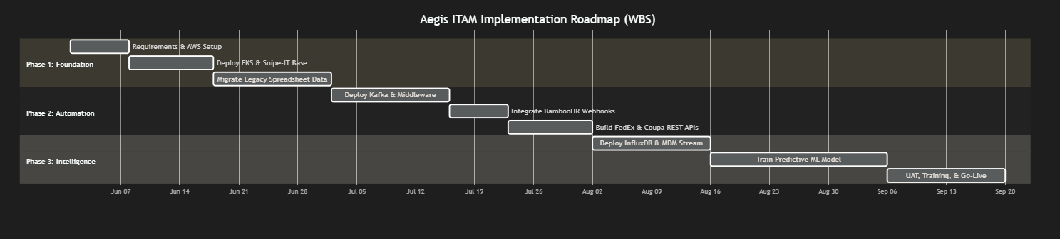

3. Risk Management Matrix
Modernizing an enterprise IT architecture carries inherent technical and operational risks. The table below outlines the critical risks and their planned mitigations.
Risk Area | Description | Probability | Impact | Mitigation Strategy
Data Migration | Legacy Google Sheets contain massive inconsistencies, duplicate serial numbers, and missing assignments. | High | High | Implement a rigorous Python-based data sanitization script prior to Phase 1. Force a physical "barcode scan audit" for all Manila/Cebu clinic hardware to establish a clean baseline.
API Rate Limiting | BambooHR and Coupa APIs enforce strict rate limits. A mass-hiring event could cause the system to drop webhooks. | Medium | High | The architecture specifically utilizes Apache Kafka (Amazon MSK) to buffer incoming payloads. If rate limits are hit, the Event-Driven Middleware will throttle outgoing requests and retry automatically via Temporal.io.
Network Latency | Streaming live telemetry from 400 remote telehealth doctors into InfluxDB could cause bandwidth bottlenecks. | Medium | Low | Configure the MDM agents to aggregate telemetry locally and send batched updates every 15 minutes, rather than maintaining an open continuous TCP stream.
User Adoption | Remote doctors may ignore automated FedEx return emails generated by the system during offboarding. | Low | High | Integrate the HR payroll system into the Temporal workflow. If FedEx API does not register a tracking scan within 14 days, automatically trigger an HR hold on final severance pay.

